**Medieval Playground**

Made by:

Brinzea Alexandru

Gidea Andrei

Manea Andrei

Panait Andreea

**Group 233**

1. **Product Description**

**Medieval Playground** is a two-player cooperative arcade game, where the two main characters are **Dragon** and **Knight**. Players have to work together and use each character's skills to beat the puzzles and finish the levels successfully.

The controls are simple: Dragon is controlled by the arrows, while Knight is controlled by WASD. Each character can touch the spikes matching their own color, whereas the green spikes are fatal for the both of them. The goal is to reach the door corresponding to their colors.

**Key:**

|  |  |  |
| --- | --- | --- |
|  | **Dragon** | **Knight** |
| **Appearance** | C:\Users\Andreea\Desktop\2019-05-30 16_51_53-Window.png | C:\Users\Andreea\Desktop\2019-05-30 16_52_00-Window.png |
| **Harmless spikes** | **C:\Users\Andreea\Desktop\2019-05-30 17_01_09-Window.png** | **C:\Users\Andreea\Desktop\2019-05-30 17_01_02-Window.png** |
| **Fatal spikes** | **C:\Users\Andreea\Desktop\2019-05-30 17_01_17-Window.png**  **C:\Users\Andreea\Desktop\2019-05-30 17_01_02-Window.png** | **C:\Users\Andreea\Desktop\2019-05-30 17_01_17-Window.png**  **C:\Users\Andreea\Desktop\2019-05-30 17_01_09-Window.png** |
| **Door** | **C:\Users\Andreea\Desktop\2019-05-30 17_01_25-Window.png** | **C:\Users\Andreea\Desktop\2019-05-30 17_01_31-Window.png** |
| **Props they can interact with** | **C:\Users\Andreea\Desktop\2019-05-30 17_01_38-Window.png** | |

1. **Level 1**

**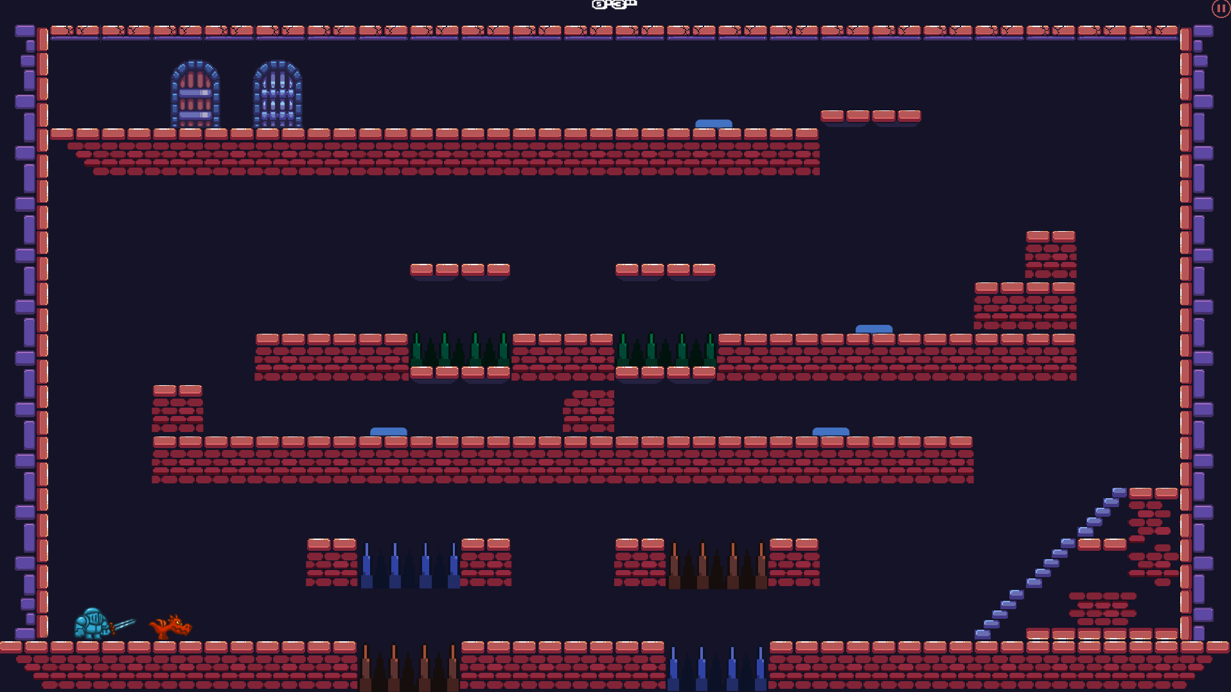**

Dragon must walk through the red spikes and Knight through the blue ones until they reach the 2nd floor. Once there, they must work as a team, with one of them pressing the button while the other one passes under the moving brick tile; afterwards they switch roles. On the 3rd floor, the characters have to jump over the green spikes. When they reach the button, the solution is identical to the one surrounding the first two buttons. Finally, they reach the doors leading to the next level.

1. **Level 2**

**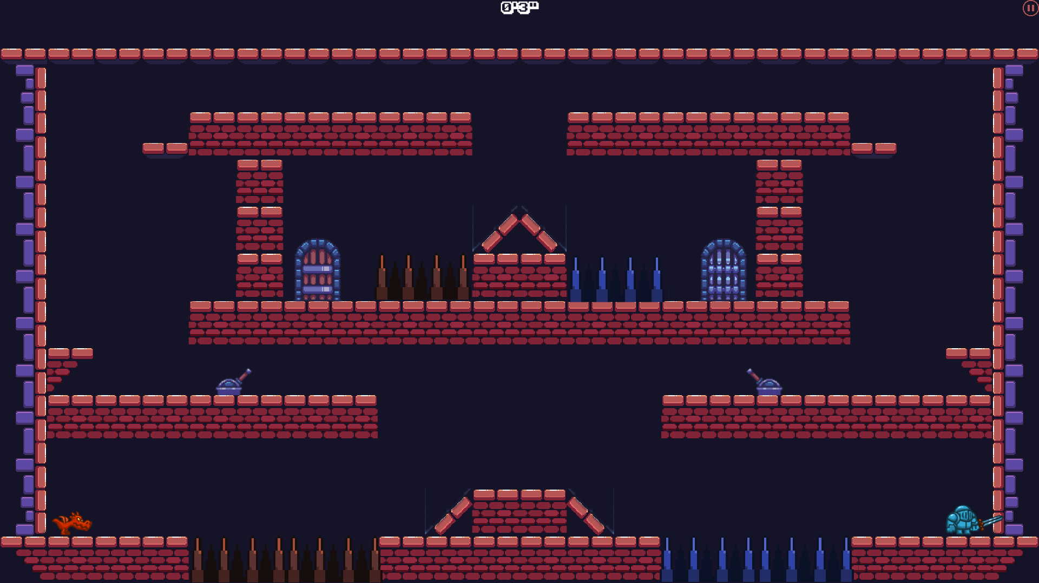**

Both Dragon and Knight have to get on the platform from the middle. From there, they’ll have to jump on the 2nd floor. They will each find a lever that makes another brick platform appear, that will help the characters to get on the room where their doors are located.

1. **Level 3**

**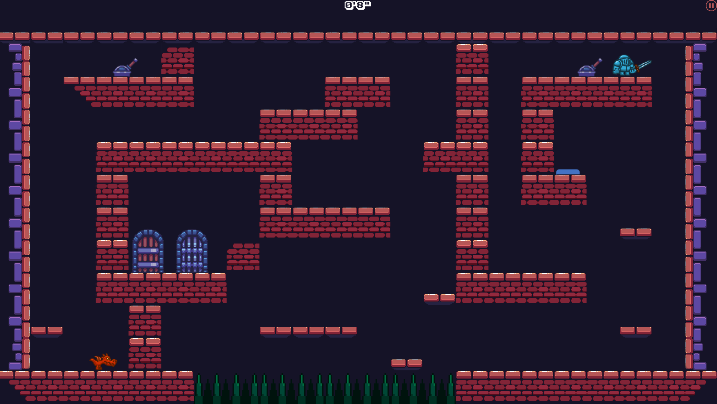**

Dragon has to jump on the platform next to him which will then move upwards after Knight uses the lever. The button near Knight will activate the brick tile blocking the entrance to the lever in upper left corner which will become accessible to Dragon. The aforementioned lever will trigger the brick tile obstructing the doors. Both characters will then have to avoid the green spikes in order to reach their own doors.

1. **Level 4**

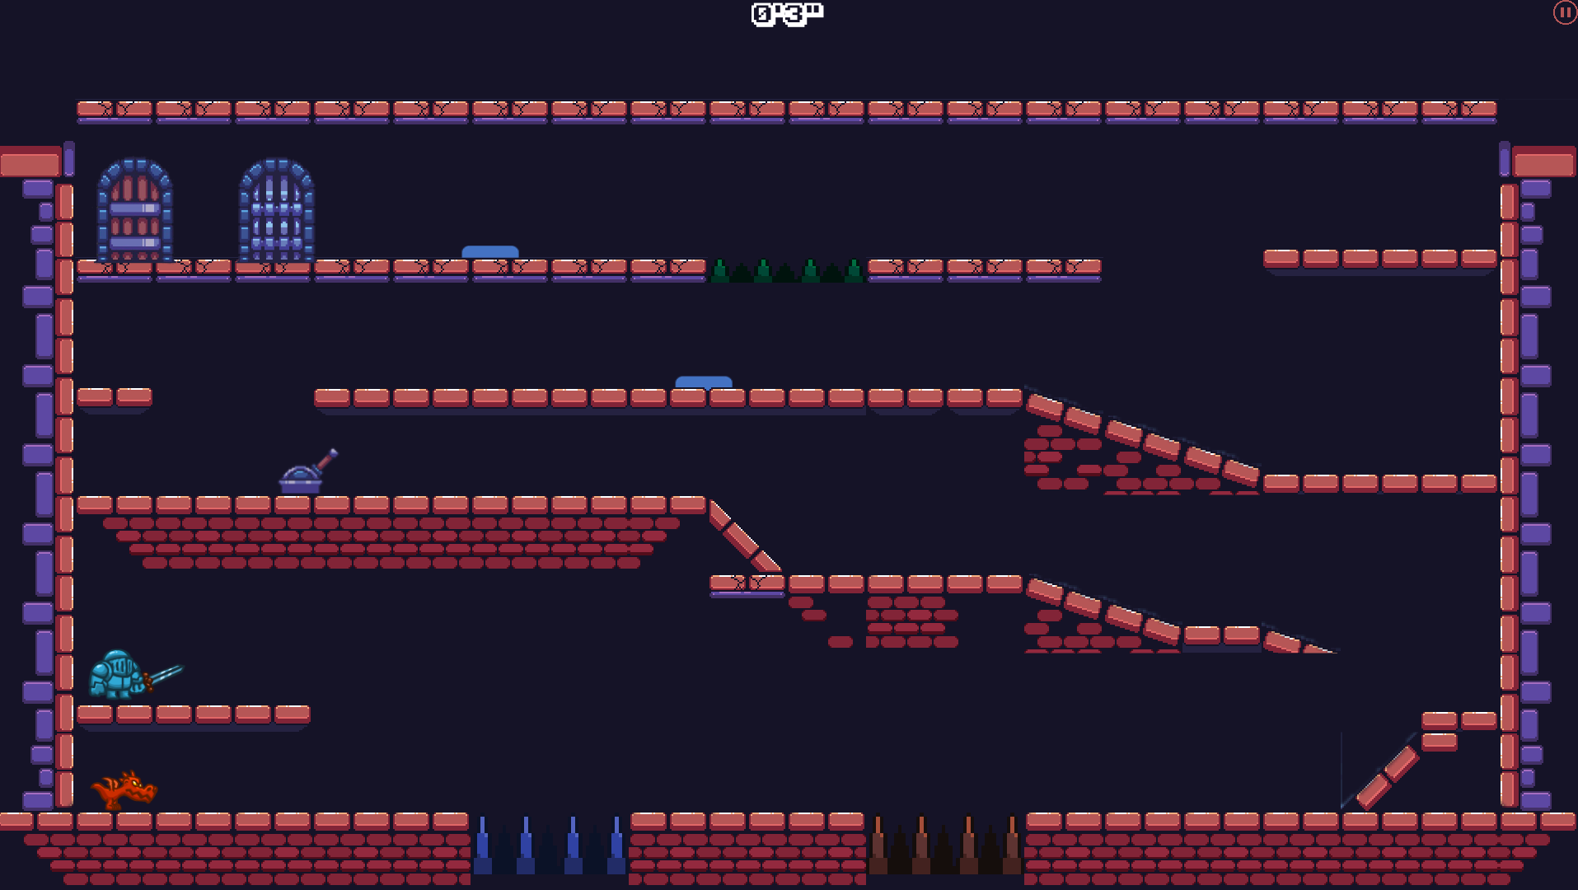

Because this is the last level, we made the jumping height of each character lower, in order to deliver a more challenging experience. Both Dragon and Knight start from the same point approximately, and each of them has to avoid their fatal spikes in order to get to the second floor. There they will encounter a lever that will lower a brick tile, so they could jump onto the next floor. On the 3rd floor we will find a button that will lower another brick tile that will help one character reach the final floor, where another button is located. The character that is now on the final floor will have to press to button in order to help his friend get on the final floor too. On the 4th floor, they have to avoid the green spikes, and then arrive at their designated doors.

1. **Main Menu**

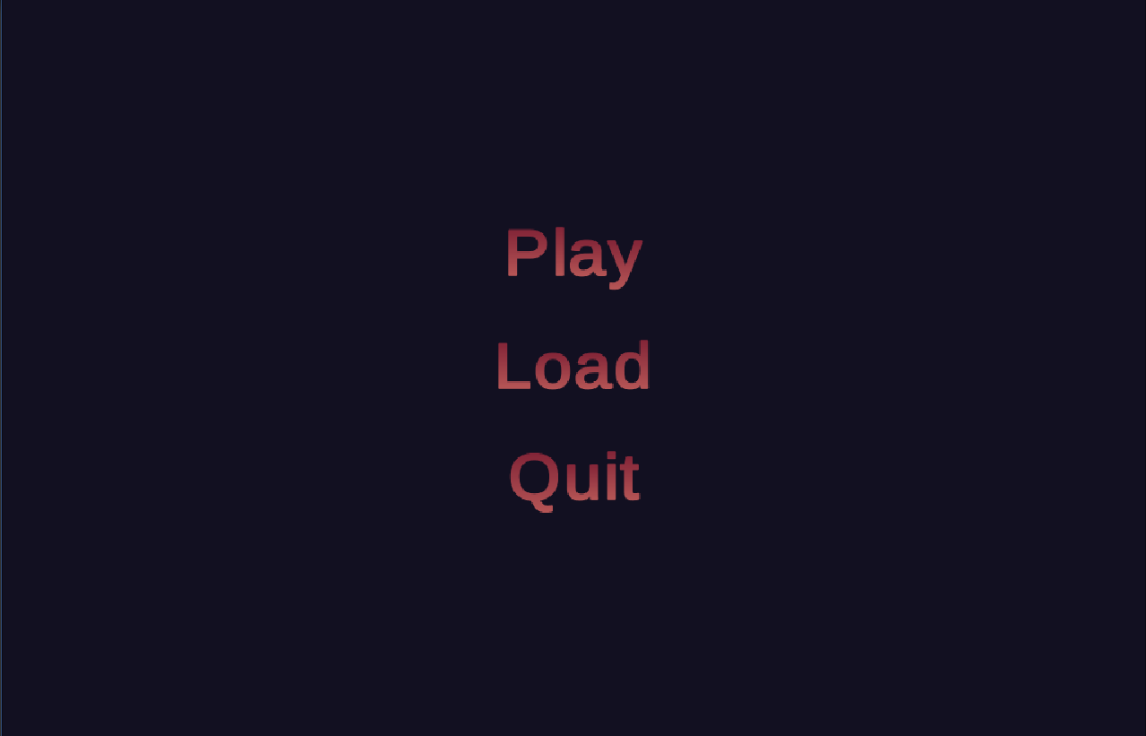

The Main Menu has three buttons: Play, Load and Quit. The Play button starts the game and the Quit one exits to desktop. The Load button allows the user to continue the game from where they last saved their progress.

1. **Pause Menu**

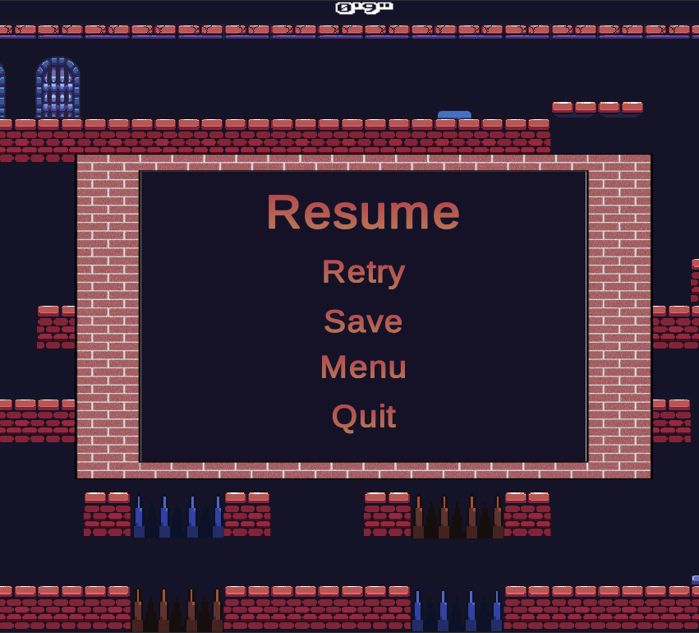

The Pause Menu consists of five buttons. The Resume button closes the Pause Menu so that the players can continue their game. The Retry button restarts the current level. The Save button collects the data into a separate file so that the player can continue the game from this point next time they wish to play. The Menu button returns to Main Menu and the Quit button exits the game.

**Animators**

1. 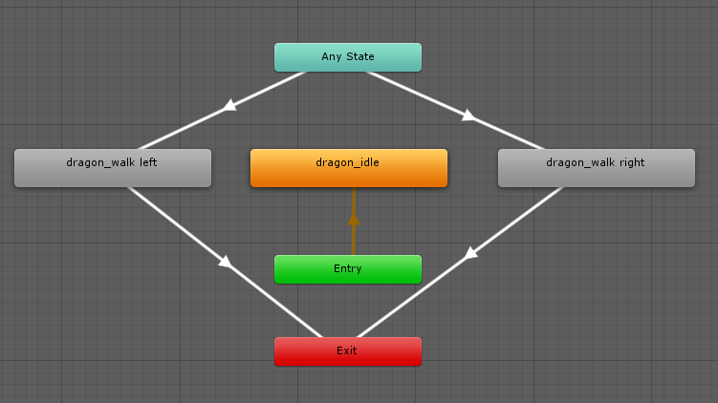**Dragon Animator**

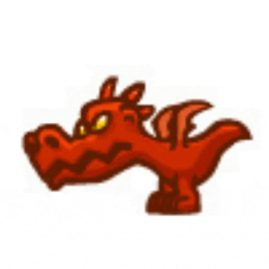On each frame of the game, when the Dragon is not moved, an idle animation is displayed.

When you press the ← or → buttons, the motion animation is called and changed once per frame.



1. **Knight Animator**

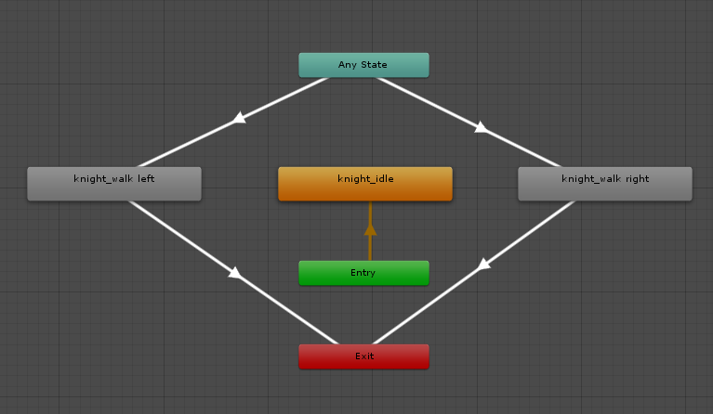

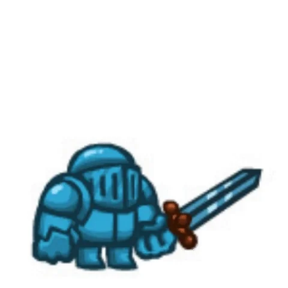On each frame of the game, when the Knight is not moved, an idle animation is displayed.

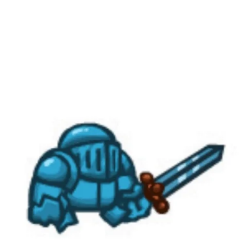When you press the A or D buttons, the motion animation is called and changed once per frame.

1. **Level Changer Animator**

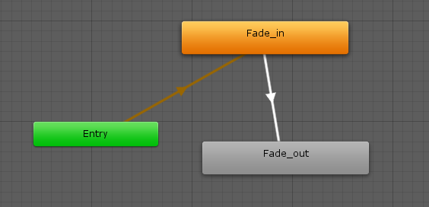

When a scene is loaded, the state changes to Fade In and the corresponding animation is called.

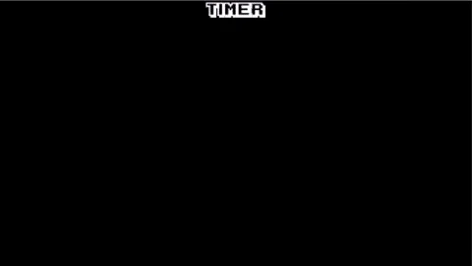

When both players reach the two doors corresponding to the characters they play, the Fade Out animation is called.

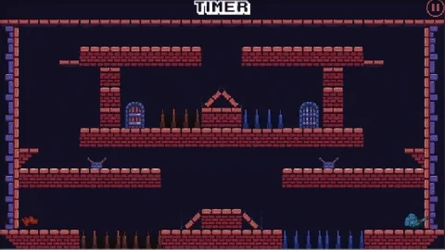

The end of the Fade Out animation activates the loading of the next scene in the game.